App Documentation

**Technologies used:**

Our app was developed using MIT App Inventor, a beginner friendly web application that allows you to build an app for Android or IOS.

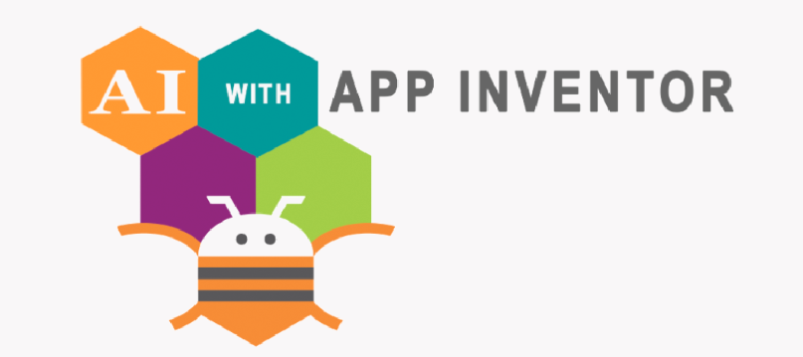

It uses a graphical user interface (GUI) very similar to the programming languages Scratch and StarLogo which allows users to drag and drop visual objects to create an application that can be tested on Android and iOS devices and built to run as an Android app. It uses a companion mobile app that allows for instant live testing and debugging.

**Hardware:**

To make the communication between the app and robot be possible we used the HC-02 Bluetooth module.

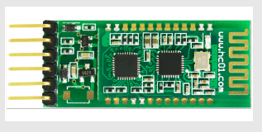

HC-02 Bluetooth serial communication module is based on the Bluetooth V2.0 Bluetooth protocol data transmission module, high stability, ultra-low power consumption, industrial grade Bluetooth data transmission module.

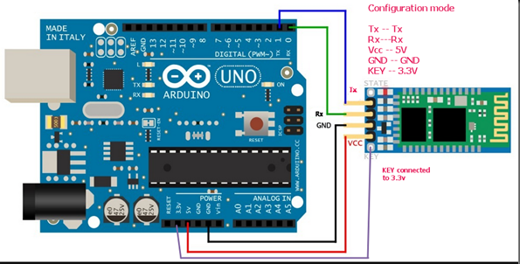

The following configuration was used to connect the Arduino Uno and Bluetooth module.

**App design:**

For our app design we wanted to go with something as simple as possible. We decided on having two buttons (one black and one white). This way the functionality of the app is very clear for the user.

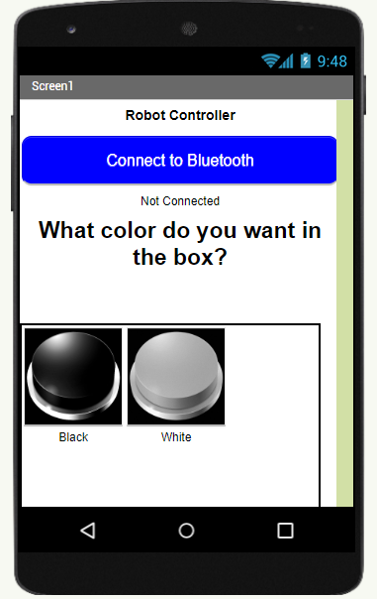

**Functionality:**

By clicking on the blue “Connect to Bluetooth” button, the user has the option to choose between the paired Bluetooth systems on his device. Once a Bluetooth connection is established, the text below the button will change to connected.

When the user clicks on either one of the black and white buttons, a message will be transmitted to Bluetooth module and our robot will respond accordingly, by switching between the color of the disks that are collected at that given moment.